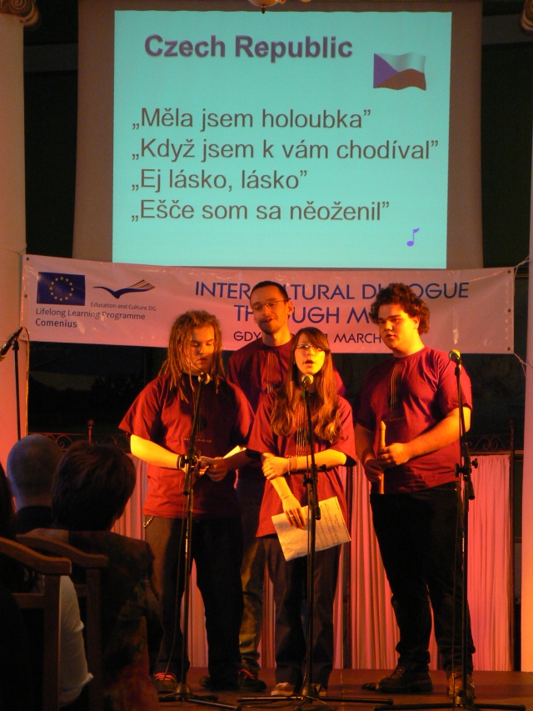
My Impressions from Poland
By Jan Krajčírovič

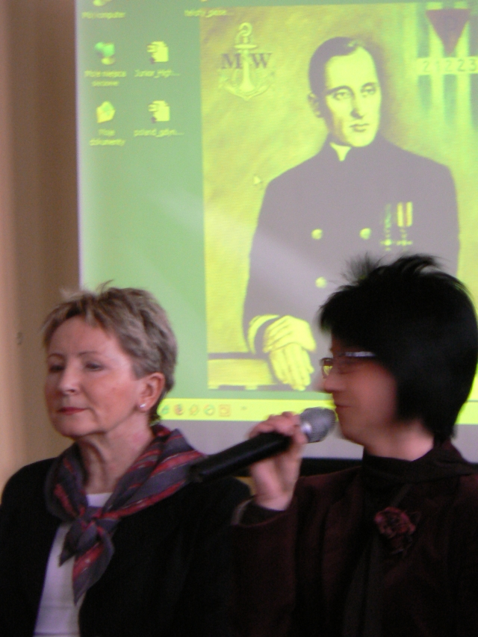
I have been to Poland for the first time. We were a group of two teachers (Dagmar Milotová and Vojtěch Dlask) and four students (Tomáš Kollár, Václav Klčo, Klára Žampachová and me, i. e. Jan Krajčírovič). We went there by train. Our aim was to represent our high school in the International Dialogue through Music project in Gdynia.
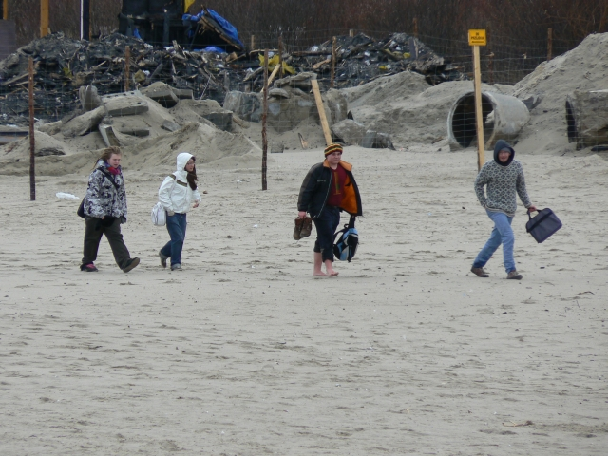
All the students lived host families which were very polite and friendly. We visited many historical places, for example Malbork, Gdansk, Gdynia, Sopot and Torun. And other interesting places like the Sea Aquarium and Museum of Gdynia. We even tried to swim in the Baltic Sea and it was very cold indeed.
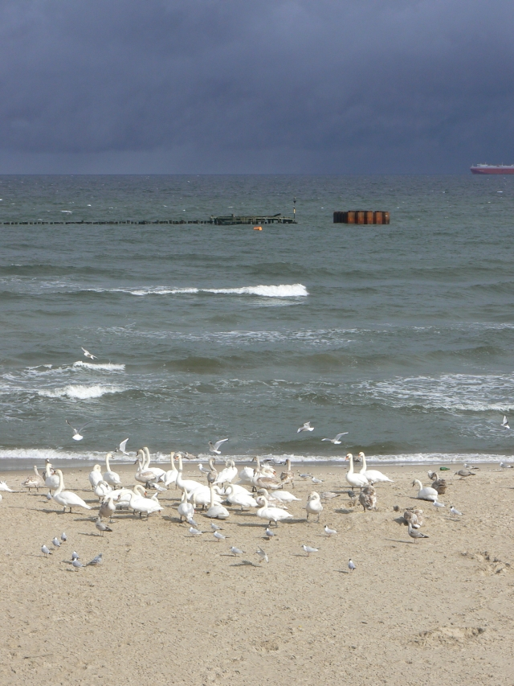
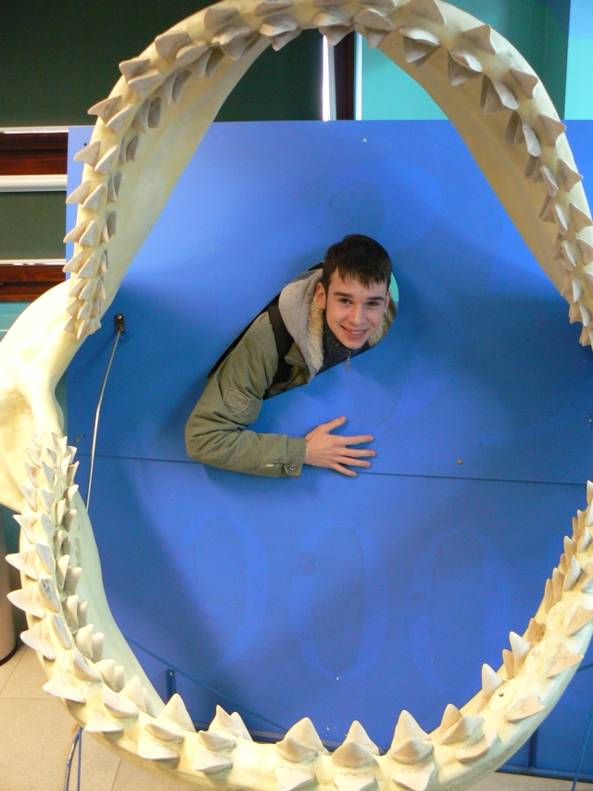
The meeting was very interesting as we met many students from other countries (Cyprus, Germany, Italia, Poland, Slovenia, England…). The weather was rainy and cold but fine. It was very useful to discover how people from other countries behave, to get acquainted with their culture.

I got new friends and I thank all the organisers, schoolmates and teachers for good atmosphere and success of the event.
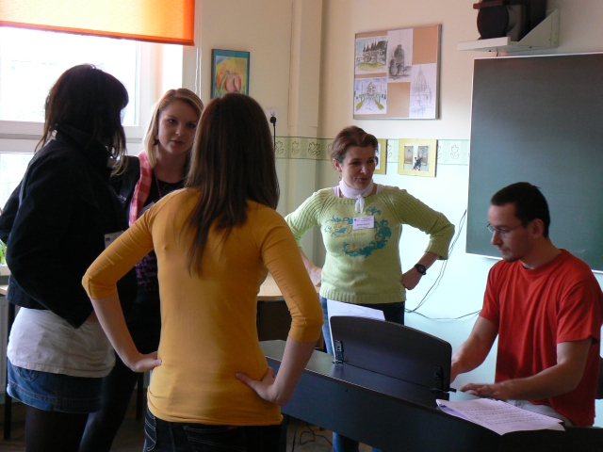
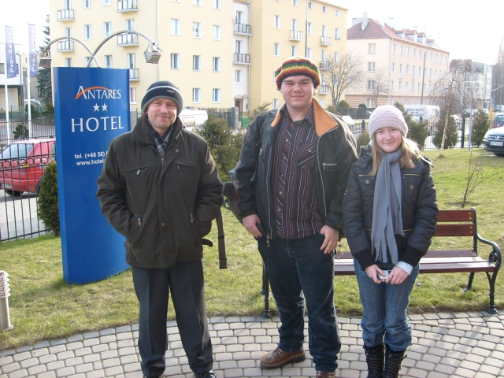

Our Stay in Poland
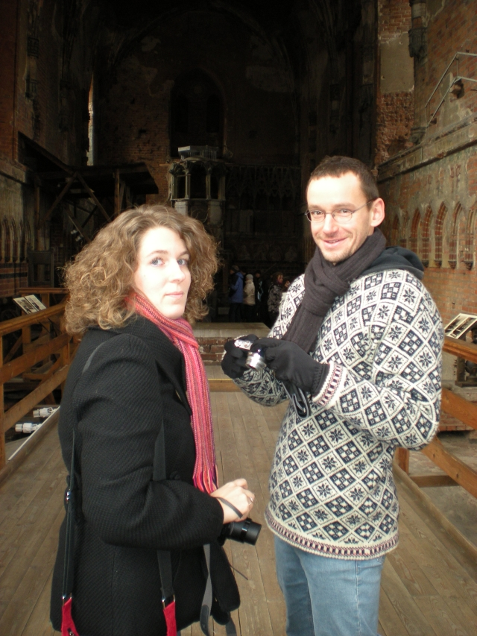
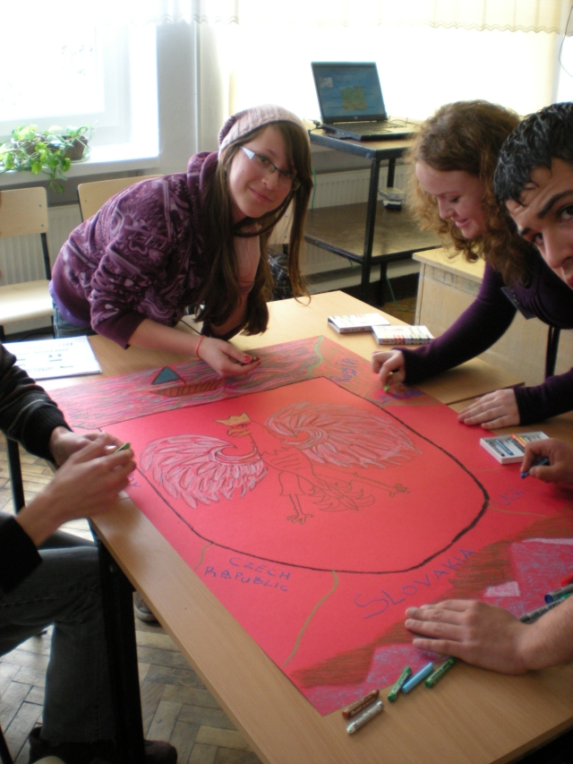
By Václav Klčo

Winter Poland is not really a nice country but there are nice cities and places like Gdansk, Warsaw and Sopot. The whole meeting was very interesting and exciting. We met many new people. And we visited lovely places like Malbork, Torun and many more. I will not forget.

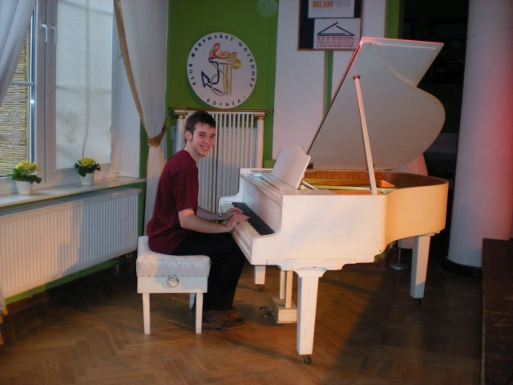
Gdynia
By Tomáš Kollár
People travel abroad to shop, work or visit other people but we went to Poland to sing and play: from 17th till 21st March, we were in Gdynia. The family, where I lived, was super. They were looking after me very well and were very kind. I had a single room and the family had a dog named Lucy.
During our stay we visited a lot of monuments and castles, e. g. a beautiful city of Gdansk or the Malbork castle. The places, which we visited, were absorbing, but excursions were very long. I was really dog-tired.
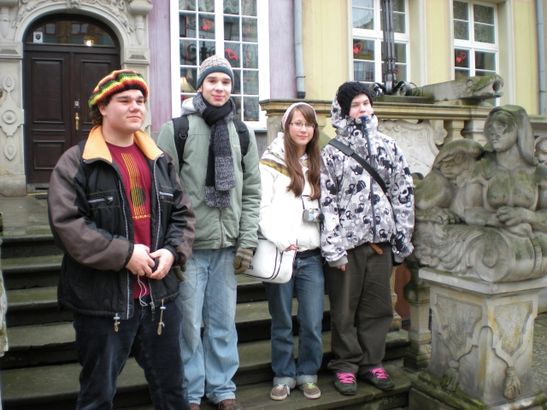
I did not notice any big differences among the Polish and Czech people. The Polish people were peaceful and religious. And also did not seem extremely rich. I met many new friendly and accommodating friends from Poland.
The journey back home was extreme. We went by train almost twenty hours. In Poland, I liked it but I looked forward to my homeland.

