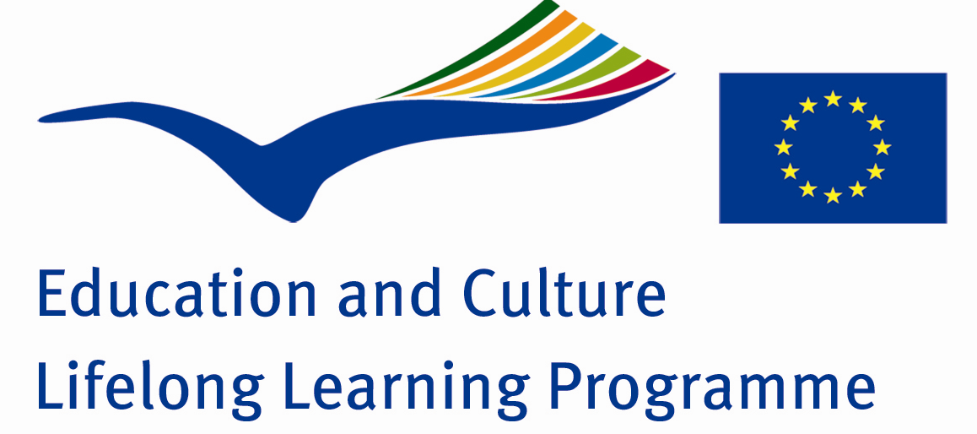

Intercultural dialogue through music

FIRST MEETING IN SLOVENIA
Konjice 19- 23 January 2009

Students` impressions from Slovenia .

Stanislav Arabadjiev :

In Slovenia I was impressed most of all by the people. There is some peculiar unity among them and they are extremely hospitable. But the strongest impression was the fact that the Slovenians have strong nationalistic spirit and respect for their culture, language and music. Everywhere we were listening to Slovenian music and everybody was singing Slovenian songs. My host mother was listening to Slovenian music while she was cooking. At school and when we were out in the evenings ,all the students were singing Slovenian songs. That impressed me a lot.

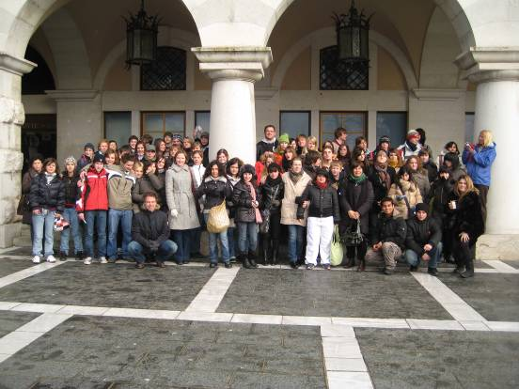

I will always remember this meeting because of the people I met, the new friendships, the amazing girls from all the school partners .

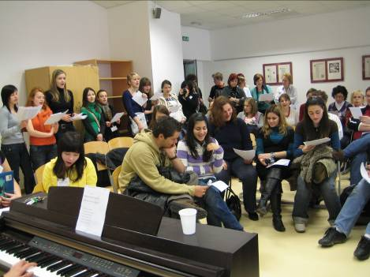
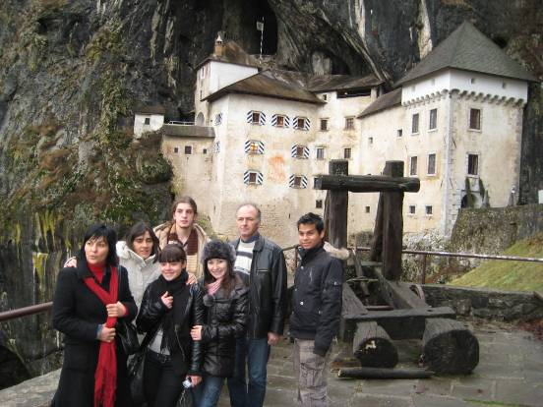

It was very interesting for me to see Ljubljana, the castle…..

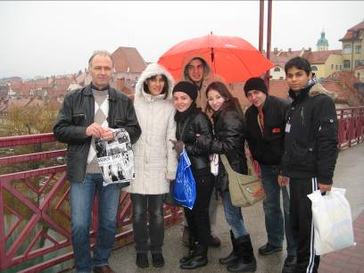
…..and Maribor.

Nanyu Lazarov

In Slovenia I was very impressed by the organization of the meeting. The people in Slovenia are very nice ,kind and hospitable. One of the most beautiful places we visited was the Postoina cave.

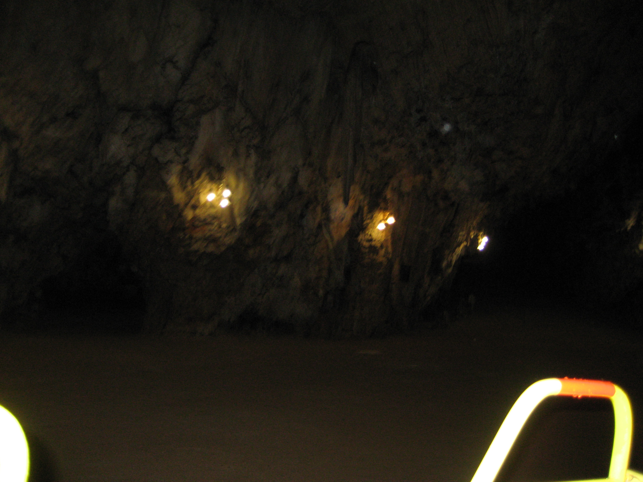

It was a great experience which I had never had before in my life. It was a great pleasure to meet so many new friends and different people.

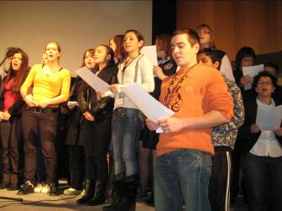

Nikolet Cholakova

Slovenia is a small European country which can impress anyone with its culture. The distance between Bulgaria and Slovenia is so small , but Slovenia is too different.
My first impression was that everywhere you see beautiful and neat houses, streets, gardens.

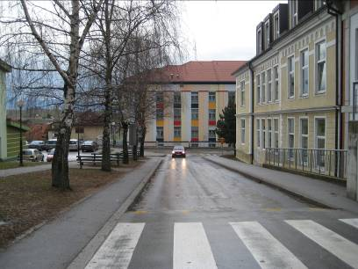

I liked the churches here and interesting museums in Maribor.

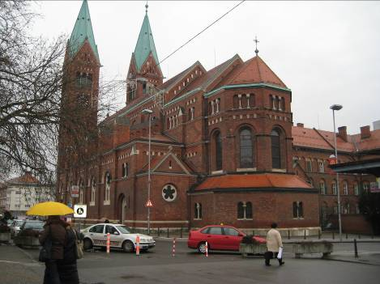

The typical drink is the wine traditionally prepared for centuries. We saw the well –known wine – cellar in Maribor.
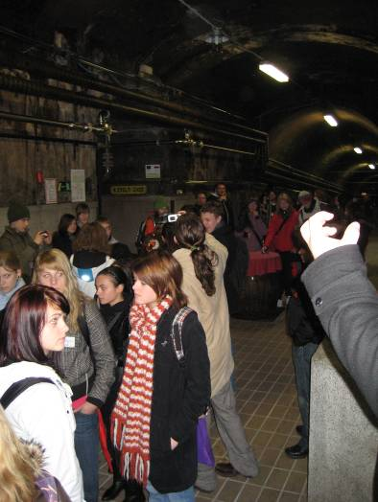

The meeting was perfectly organized. We had group work to practice our project Friendship dictionary.
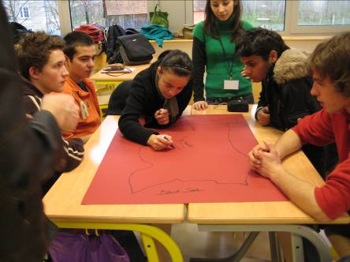

It was so funny and nice to make exercises trying to speak one and the same words in 8 different languages.

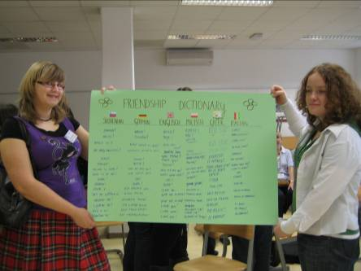

Music lessons were just great! Each music teacher from each partner school was teaching us to sing their national song.

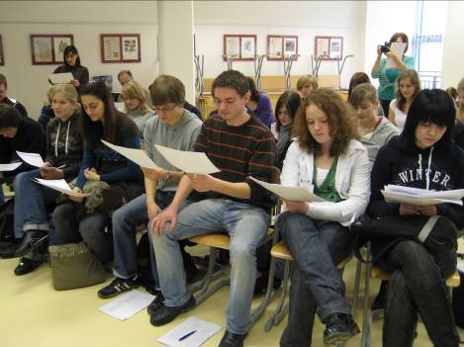

We were singing together and it was a magic –different nations to sing national songs in their national languages. The music lessons created a strong friendship spirit and I was so proud to be part of it!
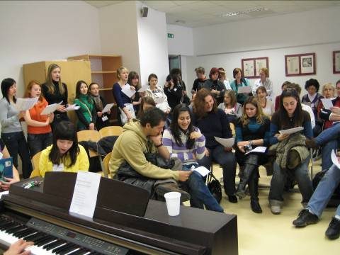

The concert was a small picture of our common European home.

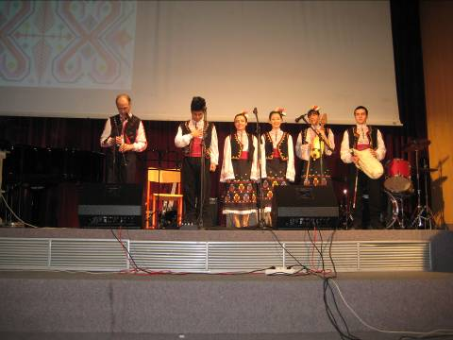

We are totally different , but everyone is important and together we can create a great things!

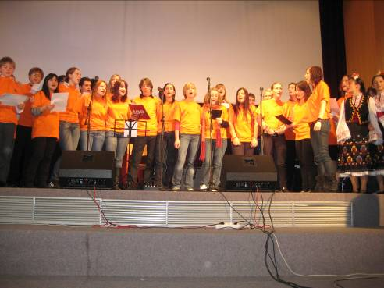
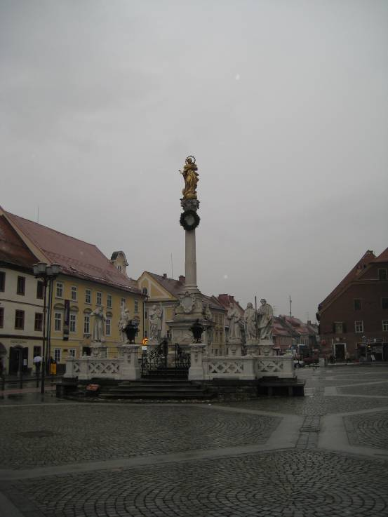

At the end I want to say that if you want to know Slovenia well ,you have to live in Slovenian family for a couple days. It is the best way. I am thankful that I had this chance.
Slovenia is a proof that “in small packing are hidden the best presents”.

