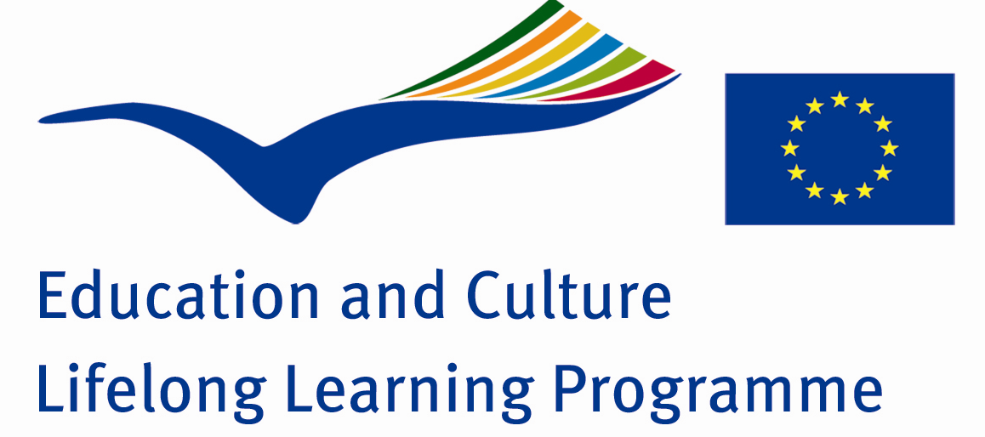

Intercultural dialogue through music

SECOND MEETING IN POLAND
Gdynia 17-21 March 2009

STUDENTS `IMPRESSIONS FROM POLAND:

Tsvetelina Bashkehayova,Radostin Tonev,Milena Zhelyazkova-
We liked Poland very much! We were impressed by Gdynia- a big and beautiful city near the sea with lots of interesting places to see. You can enjoy here with the wonderful nature and architecture of the city.
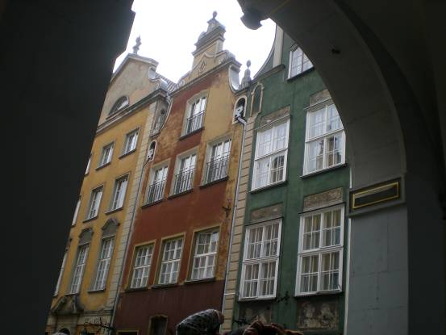

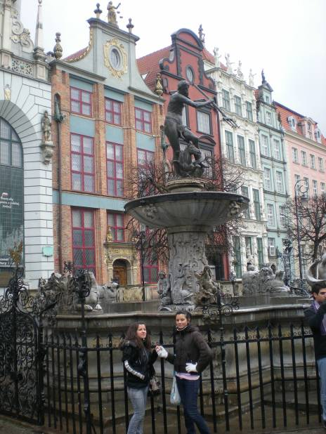

We also visited Sopot and Gdansk …….
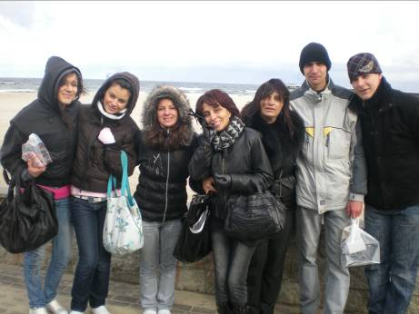

……but we liked mostly the history museum and the Aquarium of Gdynia.

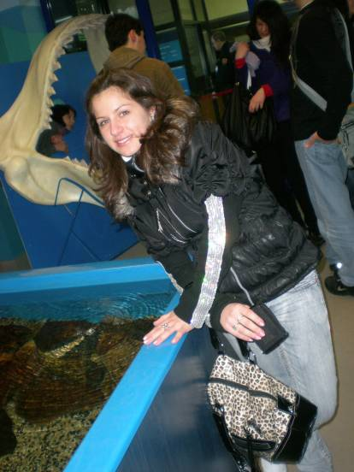

The organization of the meeting was perfect. We were very kindly welcomed in the town hall. It was such a nice experience to meet so many different students from different countries and make friendships with them. The time we spent together was fantastic.

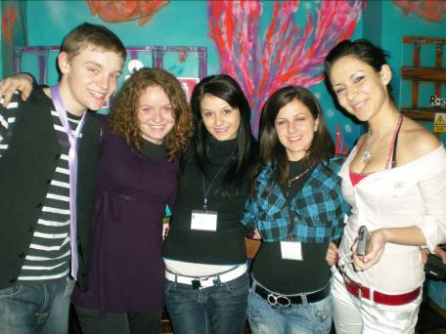

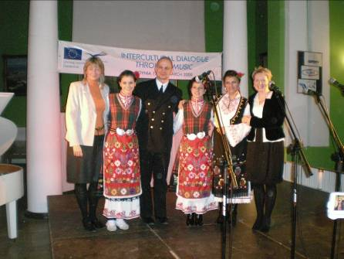

To make a concert together was an amazing idea and great experience for each participant.

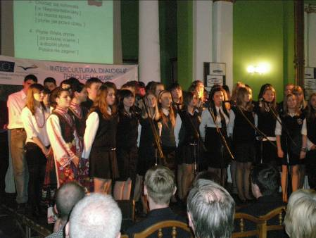
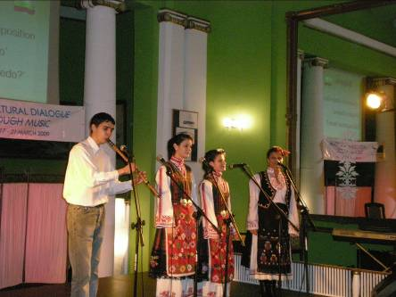

That trip ,being involved in that project and in the meeting in Gdynia will remain a nice memory for us and will be one of our greatest experience .

