Our Stay in Slovenia (by Jitka Pospíšilová)

I had heard that Slovenia is a nice country but when I came there I was surprised: there was a beautiful countryside and very nice people...
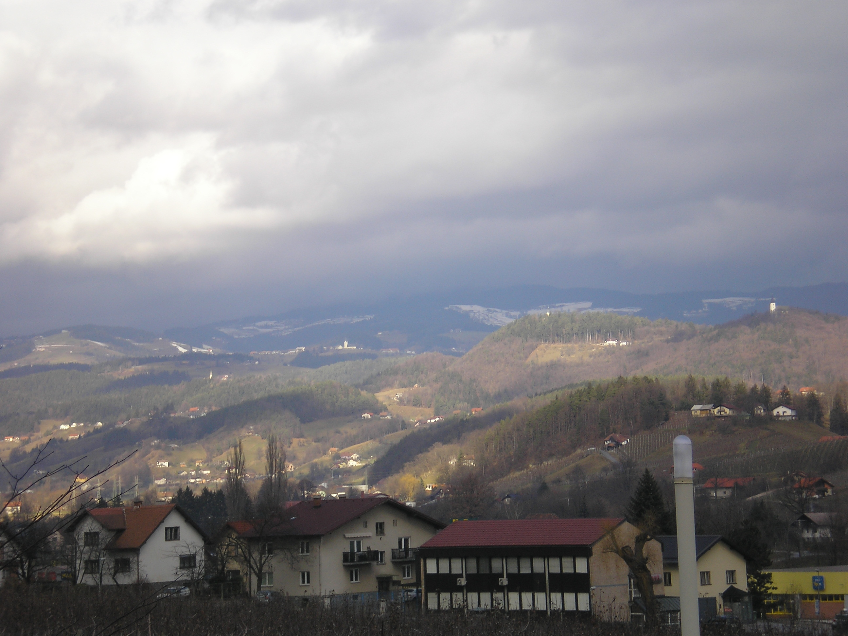
Especially the nature amazed me. Everyday when my Slovenian friend Kornelija, her mum and I went to school and back with her dad, I was looking from the window from car and simply felt amazed. The scenery there was so beautiful. There were many hills and almost on each of them there was a little chapel. There were not many villages but a lot of detached houses. I really liked it and I think this is one of the most beautiful things about Slovenia.
And I have not mentioned the Postojna cave yet! It is one of the greatest things I have ever seen! In the caves there was a lot of free space! I took so many pictures that I had to delete some. :-) There were many amazing things that I wanted to take a picture of; I just could not help it.
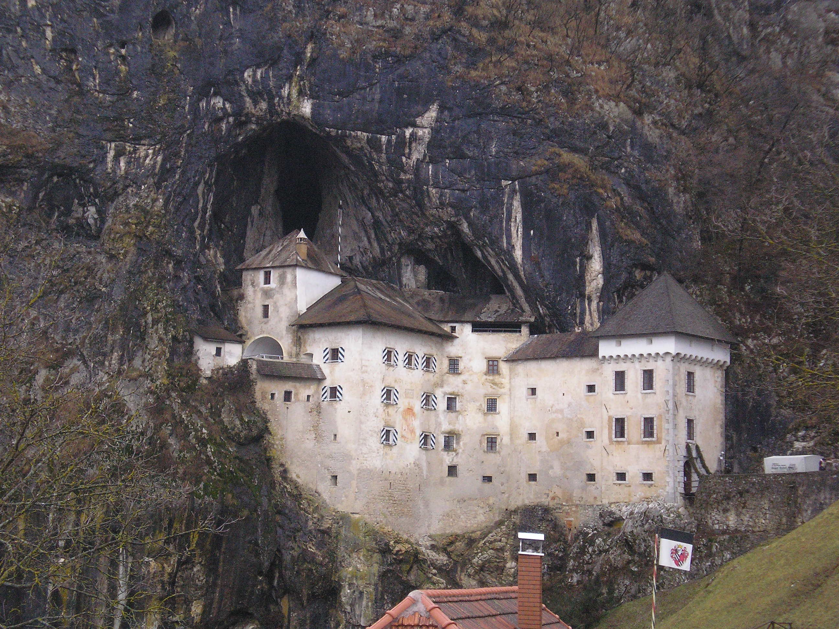
And also that castle in the rock was very good. It is so unusual!
And another thing that surprised me - the people. You know, wherever I came, people were polite but in Slovenia they were extremely nice to me. They kept asking me if I needed something and if they could help me somehow. I was shocked! Not even in the Czech Republic people are so polite!
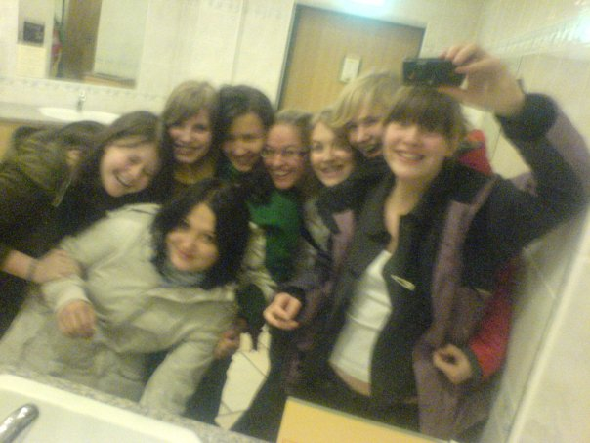
I am very grateful that I could visit Slovenia, meet so many nice people, see so many interesting things and above all have a very funny time with my friends.
It was great and I hope that I will be able to come to Slovenia and see my friends again...
Beautiful Scenery of Slovenia (by Květa Kaláčková)

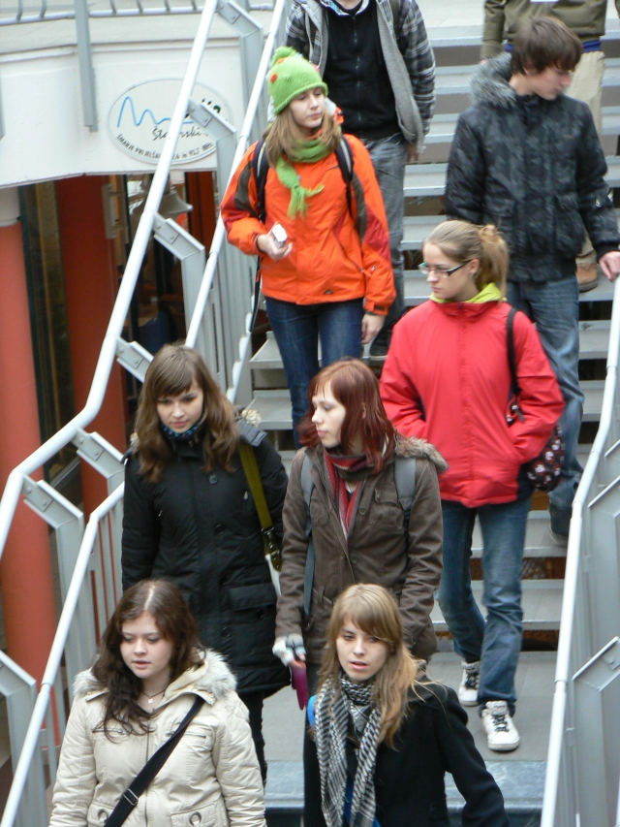
When we came to Slovenske Konjice and I saw the valley I was really surprised. Since the first moment I knew I liked it there thanks to the beautiful environment. I think that the local people wanted to have nice scenery and they took care about it. Also, there were no big villages or towns, just houses surrounded by nature. The hills with castles and churches are very beautiful.
When I was out at night I felt like in a fairytale. There was silence everywhere and the castle was so nice in limelights. And there was real darkness and no sounds of cars and people. When you are in Brno there is not real darkness anywhere and you always hear the noise of the city.
I fell in love with a park there. I mean a lake with an island and bridge. When I was there it was raining. Small drops were falling into the dark water making sounds. Light through trees made a nice atmosphere. It was so romantic! I wish we had something like that in Brno.
The local people were polite and nice, all of them smiling almost all the time. There was unbelievably good-fellowship everywhere.
I want to go to Slovenia again!

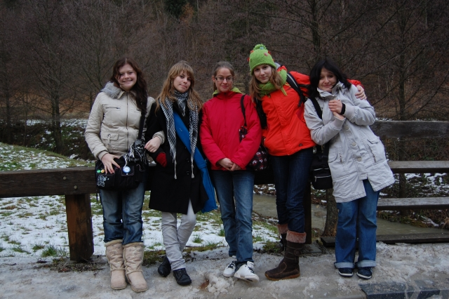
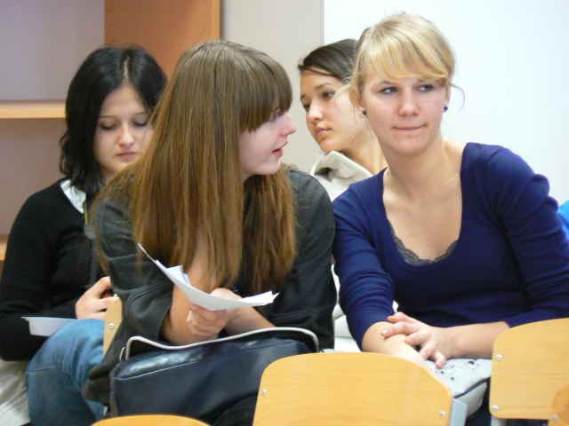
Slovenia and Its People (by Zuzana Damborská)

My week in Slovenia was one of the best school trips ever. Not only because of the school in Slovenske Konjice, friendly people, the countryside and monuments but also thanks to my host family which was my strongest Slovenian experience.
My host family was the type of host family which will do everything for you, always give you what you want and the best they have. When I saw them first I was surprised how generous they were. They were something like my own family. I “had” a very clever, handsome, little and funny brother called Jan, who was always smiling at me and trying to say something in English. Also the parents were always polite and behaved as if I were their own child, especially mum, I want to thank her for cooking, her dinners were delicious. And then Lavra my host-sister girl was very cheerful, pretty, intelligent and great. We could speak about everything and there were no problems with talking to each other in English. I am glad that I was living with such a good family and that I had the possibility to spend such great time with them.
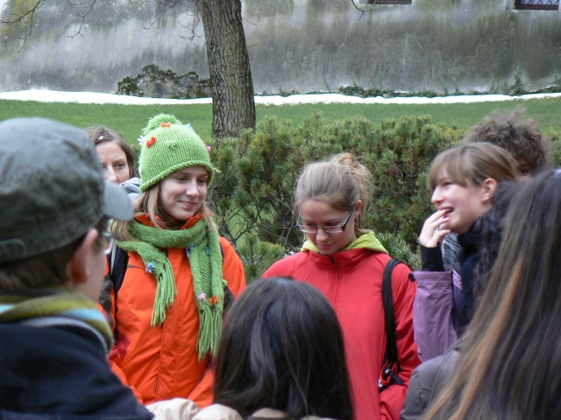
The countryside was also beautiful. Green forests and fields with sheep. The most beautiful monument was Žička Kartuzja. The energy in this place was magical and soothing. I would like to go there again some day. The day in Ljublanja was also nice but we were there only for two hours which was less than most of us wanted. But it looked like a beautiful city with lively and romantic atmosphere.
The school was well equipped and modern with young teachers (or maybe I saw only young teachers). Mostly, the people were nice but not everybody was as friendly as our host girls and boys. ☺
So I can say this week in Slovenia was successful – as for our relationships, singing in the big concert, food, people and sightseeing. I am glad that you organisers gave me this opportunity to learn about Slovenian culture and get new experiences. Thank you very much. ☺
Czech Republic vs. Slovenia (by Karolína Šimková)

When we arrived to Slovenia we were really excited about our host families. Later on, we went to the school, which was really beautiful and big (our school is also beautiful but not big), and then the host families were coming. Every host family with the host children was really nice, I think. There are nice people in our school, too, but we cannot host other countries as our school is small. In our school, we have got three artistic branches: music, drama and fine arts. However, the Slovenian school was a “normal“, non-specialised school, I think, so it was an interesting change. The students could sing, so it was OK. Slovenia has got very old historic places like Žička Kartuzija but the Czech Republic similar ones, too. And the city, where we were, Slovinske Konjice, was surrounded by mountains so it was very interesting too: our city, Brno, has not got any mountains around. The Slovenian city was small which was fine as Brno is bigger – again, a pleasant change. There is also a lovely nature in Slovenske Konjice while in Brno you can find more buildings than trees. The school was colourful and there was a very good atmosphere but the studies in Slovenia are harder than we have, I think. What is also very interesting is that our best mark is 1 while theirs is 5 so it was a little bit confusing. Finally, we had a big concert in the hall: it was cool. We learnt the Slovenian song Pobelelo polewhich was very funny and nice.
The trip to Slovenia was really exciting.

