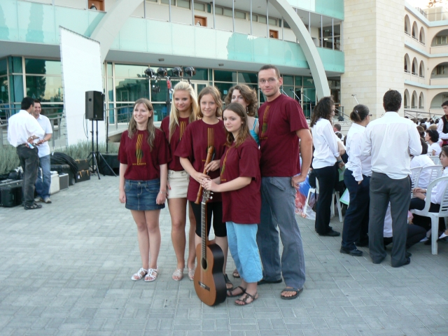
Our Stay in Cyprus
By Markéta Dolská (CZ)
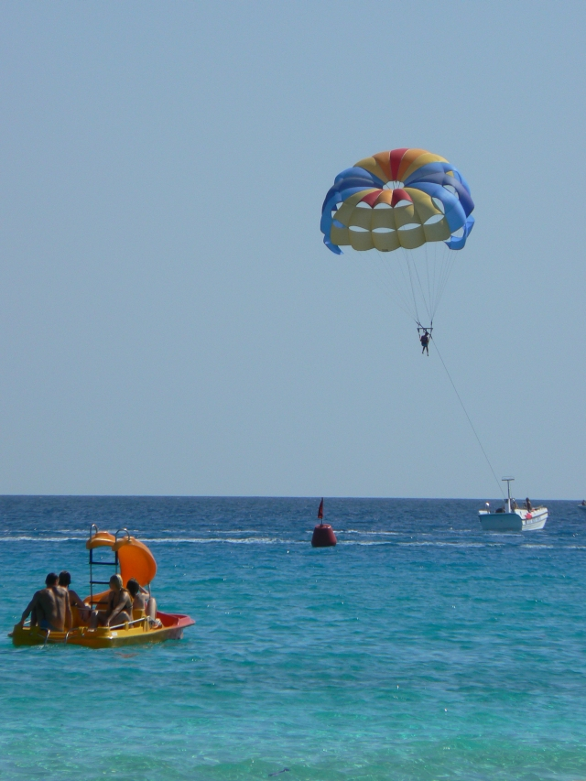
On 25th May, Míša, Romča, Lenka, me and our teachers Dagmar Milotová and Vojtěch Dlask left Brno for Vienna. We had a long night waiting for the plane to Larnaca which was supposed to leave before midnight. Though it was delayed, my first flight was really gorgeous. ☺ When we arrived to the Sun Hall Hotel in Larnaca, we looked forward to one simple thing: bed…
The next day was a free day. After delicious breakfast, we went to Ayia Napa beach for the afternoon. It was the first time I saw the sea and could swim in it. A great experience! However, some people got sunburnt as it was really very hot. In the evening, we had our dinner in the hotel along with students and teachers from other countries.
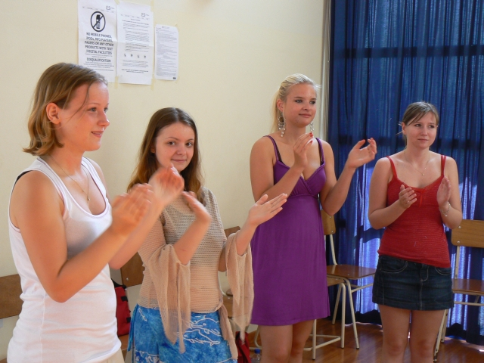
The very next morning we all went to the school to work on dictionaries. We translated sentences that we needed to be ready for the concert. Than there was a presentation by local students from the American Academy in Larnaca. In the afternoon, we went to Ayia Napa beach again. The dinner was provided in the school. The next day there was a lesson on traditional Cypriot dances in the morning which was very funny. Later on, we went sightseeing by bus to see the ruins of the antique city of Kourion, Aphrodite’s beach and the city of Paphos where we swam again.
Everybody went to see a mosque near Larnaca the next morning after a lesson on singing and painting Cypriot gourds. It was a great fun! At five o’clock, a rehearsal for the concert started. And at eight, the concert began. We sang a couple of traditional Czech songs. Our Cypriot friends had a traditional dinner with us in the late evening. They served kebab with sheep milk cheese called féta. It was excellent.
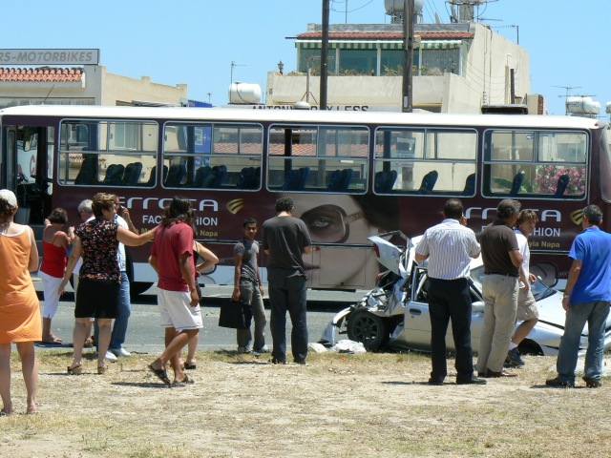
The very last day, as we were going to a beach (surprisingly Ayia Napa again :) our bus had an accident. A car crashed into it so we had to wait for another bus. Luckily, no one was hurt.
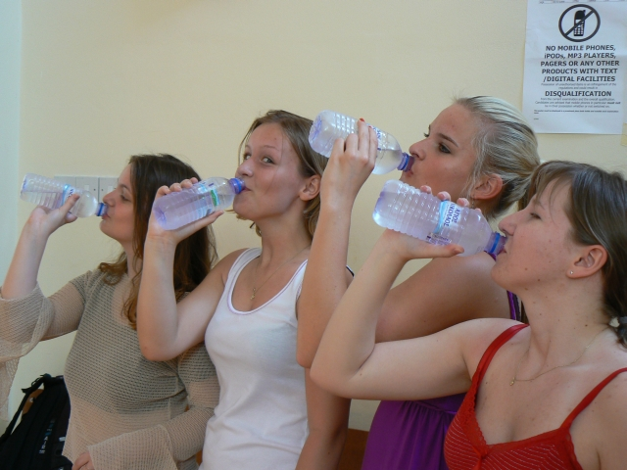
In the end, we got to Nisi beach. A lovely place! We borrowed a treadle and we also jumped from a cliff. It was super! The sun was shining, the sea was clean, blue and hot… it was beautiful!!! And again, we had to wait a long time for the flight back home. We flew to Vienna at 5.00 am. Huh!
Cyprus is beautiful. It is full of history, beautiful nature and beaches. And tourists. ☺ The project gave me a lot. It helped me improve my English as well as fight against the stage fright. I saw new culture, habits, and dances and last but not least I got to know new people. I liked our stay in Cyprus very much.
I love Cyprus.
A Few Perfect Days (Cyprus through Romana's Eyes)
By Romana Švachová (CZ)
First of all, I must admit the return from Cyprus to our country was terrible. The Czech Republic is (especially now) a quite cold and rainy land and so while in Cyprus the temperature is still around 30 degrees in May and June, here we're trembling under our umbrellas. I still remember the warm fresh sea breeze on my face...
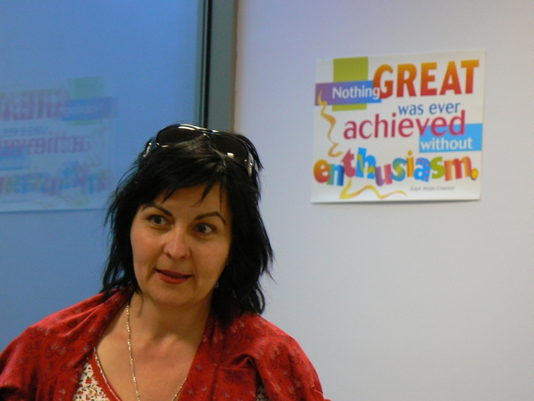
Anyway, my speech about the weather is just the beginning. As for the Cypriot people, I was pleasantly surprised by their nature. I think many southern nations have a little bit affected nature and they often exaggerate their national pride. In Cyprus, everyone was friendly, but not smarmy; nice, talkative and casual. I was feeling very good there.
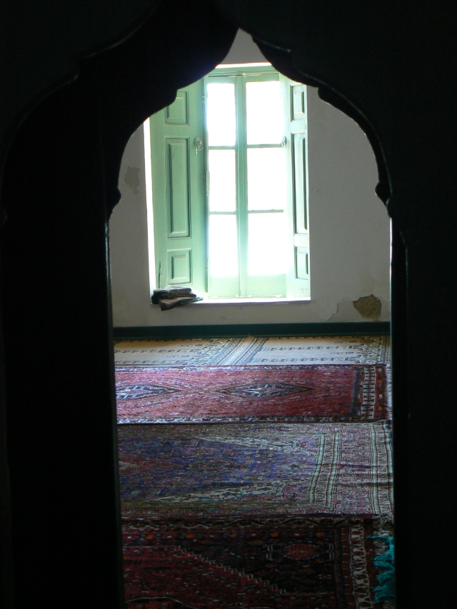
What surprised me personally a lot, was visiting a local mosque with the American Academy. I had believed that non-believers cannot enter a mosque and also that women have a separate room there. Personally, I was feeling so inappropriate there that it spoilt the rest of sightseeing. It was here that I could feel the division between Turkey and the European part of Cyprus more then elsewhere.
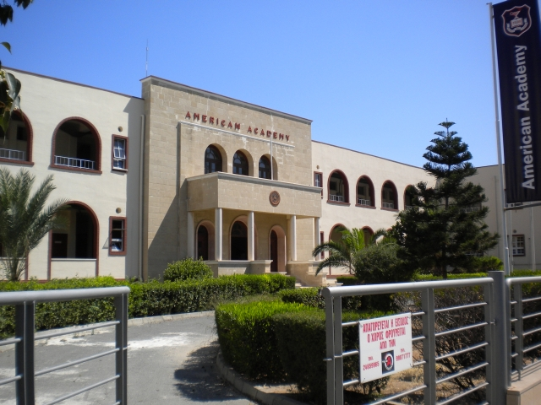
Overall, I can say I really liked our stay in Cyprus and the way the American Academy treated us including the final concert performance. At home, on my table there is a painted gourd which reminds me of those perfect days...
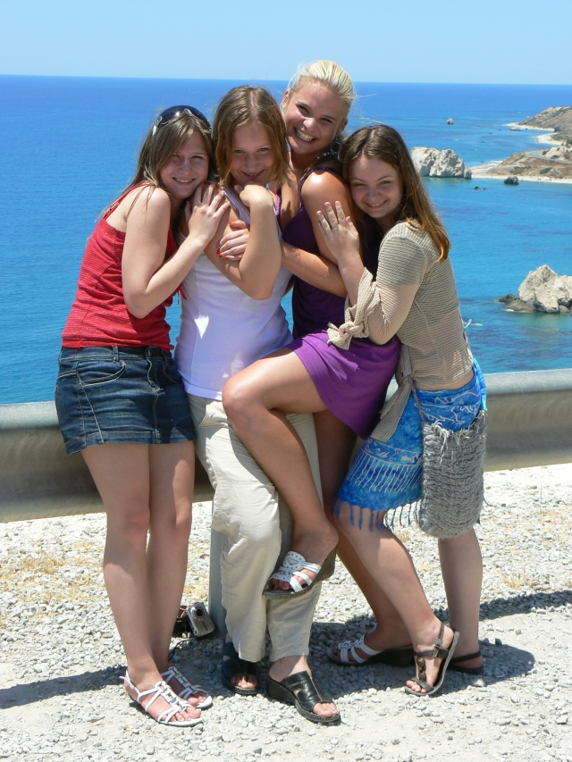
Our stay in Cyprus
By Lenka Kovačová (CZ)
It was the 25th May when our group (Markéta, Romča, Míša and me as well as Dagmar Milotová and Vojtěch Dlask, the teachers) left cold Brno heading for the island of sun, warm sea and the beach of Aphrodite. Sunbathing, palm trees, bathing, cocktails and of course singing. ☺ I am looking forward to Cyprus so much! The journey takes 12 hours. On the plane, we are trying to sleep but those of us who are flying for the first time, look as if they were willing to lean out of the windows so that they could see more, watching all the lights and shadows. Someone even shouted: “I am flying!” However, on our arrival to the Sun Hall Hotel in Larnaca, everybody slept like a log.
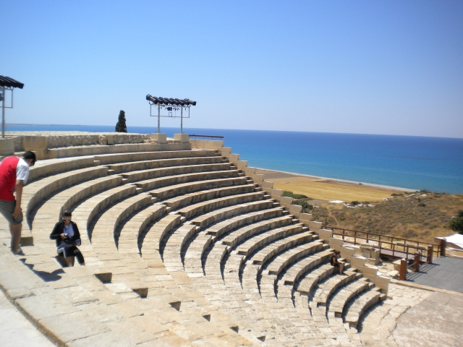
The next day we made the best of our free time which means that after the delicious breakfast we went to Ayia Napa beach. Almost everyone got at least a little bit sunburnt. In the evening, we had dinner with other students and teachers.
The next morning we went to the American Academy to work on the dictionaries and translate sentences for the concert. The students also prepared a presentation on Larnaca and the school. In the afternoon we went to Ayia Napa again and returned redder than yesterday (except for me and Markéta ☺).
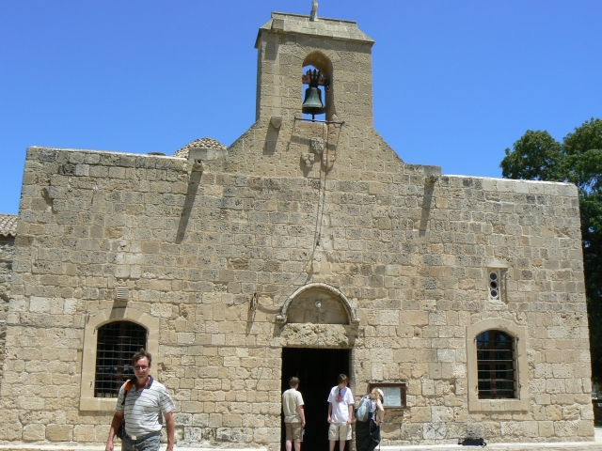
I was looking forward to the next day a lot! We went to school to learn traditional Cypriot dances. I enjoyed it very. In the afternoon, we travelled from place to place by bus sightseeing. We saw the ruins of the antique city of Kourion, tested the acoustic of an amphitheatre and looked for Aphrodite on the “her” beach. The day ended in the city of Paphos where we had a swim. What would a day in Cyprus look like without swimming in the sea! ☺
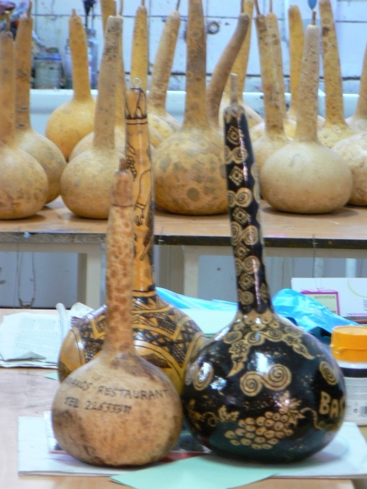
The next day we were at school again singing and painting on Cypriot gourds which we could take home with us later on. My gourd got a special place in my room. ☺ After this we went to see a mosque near Larnaca and at five o’clock a rehearsal for the concert started. We were the last group to get ready before the concert which made me nervous. There were some minor complications which made me feel even more nervous as the rehearsal did not proceed well. At eight o’clock, the concert began. My nervousness was one of the biggest ever. While standing in front of the public, I forgot it all and just did my best. All’s well that ends well. Later we enjoyed a traditional Cypriot dinner.
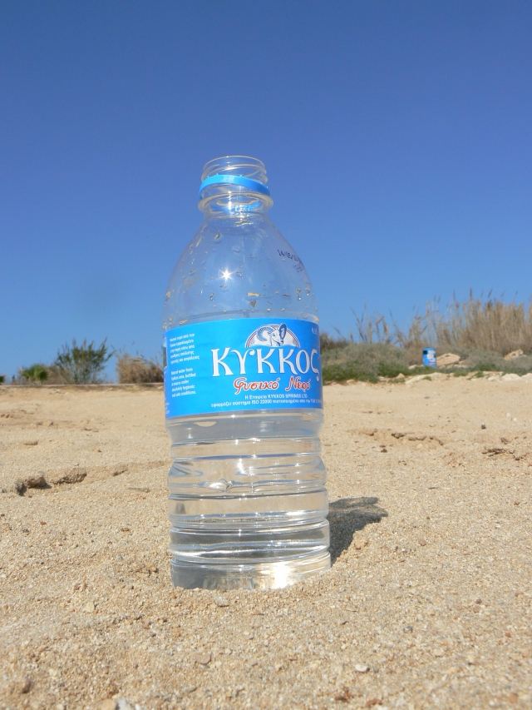
The last day we decided to go to Nisi beach again. While ridding on the bus, a car hit it. Fortunately, no one was hurt. Later on another bus came for us. Nisi beach is so wonderful place! There are various attractions and a high cliff from which we jumped and enjoyed a few second flight. This time it was me who shouted: “I am flying!”
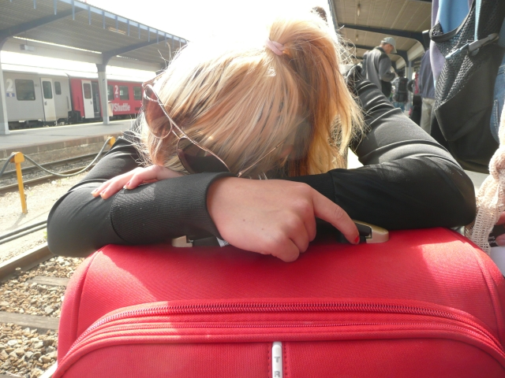
I was my first time in Cyprus. The nature and (of course) the sea was the most beautiful thing. I think that I will get back to Cyprus one day. And last but not least, the project taught me that I shouldn’t fear to speak.
Cyprus
By Michaela Osičková (CZ)
Cyprus was a salt, hot, super island. One day, I would definitely like I to come back. Perhaps when I am rich. Before we flew there, I had been worried as for the weather (I don't like high temperatures) and the local people (I hate people and crowded places). But it was OK. It was hot but the wind was blowing and people were friendly and kind. However, the superstition about people from southern countries and blond hair is really true: they were crazy because of Markéta who was very attractive for everyone – they kept inviting her for lunch or just a drink and so on.
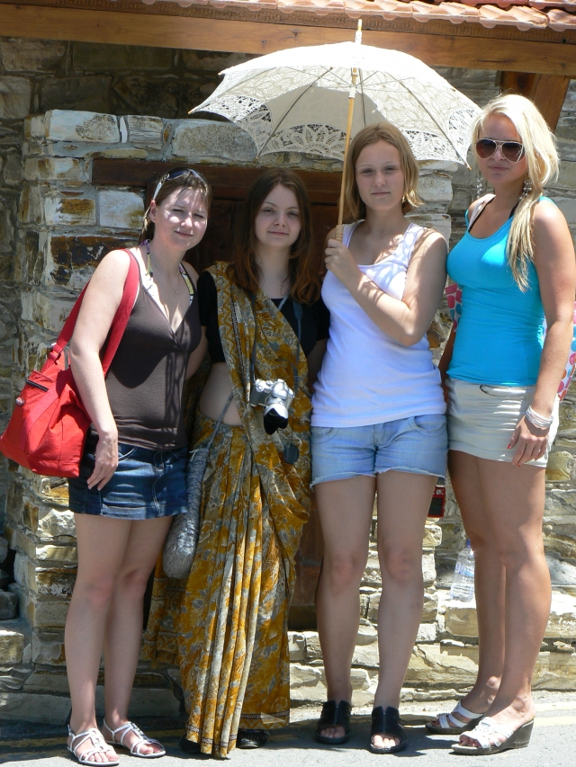
Anyway, I love the Cypriot sea. It's so clear, like a sky of blue. I saw little fish, urchins and crabs too, although I did not have diving equipment with me. It was amazing. Luckily, the program wasn't exhausting, we had good food (just one day we went to MacDonald for dinner, I mean other students went as we did not).
It was a beautiful time and I'm really very happy I was there. Just the return to school reality is a little bit harder than I had expected.
